Index

* 4 Color Process 2
* Continuous Roll (w/ slits) 4
* Continuous Roll (w/out slits) 7
* Contract Part Pricing 9
* Copying an Estimate 12
* Copying an Inventory Part 20
* Creating a New Inventory Part Number 21
* Digital Quotes Walkthrough 26
* Entering a New Die/Tooling 28
* Fanfolding on Press 32
* Flexo Quote Walkthrough 34
* Hawk Walkthrough 37
* Markup 39
* New Customers/Contacts 40
* Non-Inventory Raw Material 40
* Offline TT Quote (custom item) 41
* Offline TT Quote (stock item) 43
* OP Code Explanation 45
* Packaging 47
* Scitex Walkthrough 50
* Sheeted Items 52
* Turret/Diecutter Finishing 54
* UL Labels 55
* Combo Router – Set up Line 57

# 4 Color Process

Picking material: The higher the gloss level, the better the print quality. If a customer requests a matte or TT material, the print will not look as good as a semi-gloss or high-gloss. If printing on a film, we should suggest adding a UV varnish or laminate to protect the ink.

* Start by filling out the customer info, adding your quantities & then checking the correct location.

**MATERIAL TAB**

1. Enter all the material information just like any other flexo quote.
2. Enter die (to fill out Label Finish Info specs) & other tooling – make sure all tooling has a setup of 1, material set up & runtime, cores/boxes/bags & anything else you may need.
3. When entering the material cut, keep in mind the waste edge should be a minimum of 0.375” on each side.
4. 4 ink lines are needed for 4 color process, possibly more if there are spot colors.
5. For standard ink, type INK WATER FLEXO under the Part box or search in the browser. Tab over to the magnifying glass and the browser will open. Make sure INK WATER FLEXO is highlighted and push select.
6. Click under OP Code and select INKCOV.
7. Click on the box under Qty & fill out the formula. %COV is the % of ink coverage (if there’s 85% ink coverage enter 0.85) & %RW is % run waste (if it’s 14% run waste, enter 1.14).
8. Once you add one ink line, you can **right click** on the line & copy the row. The Qty will copy over.
9. You will have to do this as many times for as many colors you need.

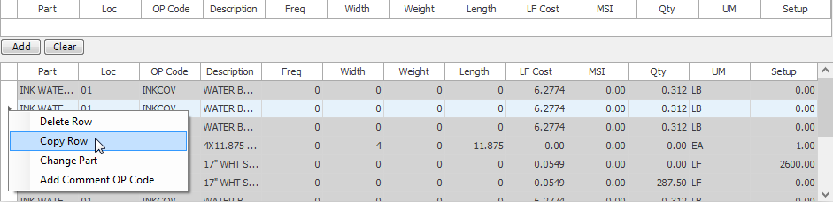

1. If there is a varnish, you can add it now as well.
2. Make sure you add any other materials you need.

**LABOR TAB**

1. The labor tab is filled out like any other flexo job.
2. You can pick a generic press here.

**PACKAGING/ATTRIBUTES TAB**

1. Fill out everything you need there.

* Check the 4 Color Process box under the attributes tab.

1. Go to Pricing tab and click refresh to get pricing.
2. For summary tab, you will need to move the lines up or down and rearrange them to put them in the order below (for the most part). You can either right click to Move up 1 or Move down 1 or if you highlight the number in the position column and enter the number you want that line to move to. If you want the line to move to 5, enter 4.5.

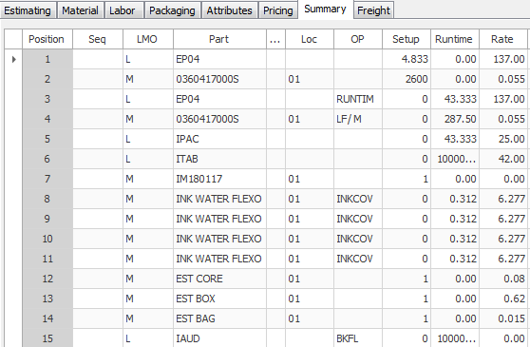

1. Things to keep in mind for combination runs:

* There is a flat $120 plate change fee if any part of the 4CP is changing. Also, add an additional $15 if there are any additional spot colors that will have copy changes.
* Add 2500’ if any part of the 4CP is changing.

1. Estimate# 780 is an example to copy from.

# Continuous Roll (w/ slits)

1. Start by filling out the customer info, adding your quantities & then checking the correct location.
2. Make sure if you are filling out the Finish Part(Label) info your UM is **RL**.
3. You don’t need a die for a continuous roll so enter all the label finish info manually.

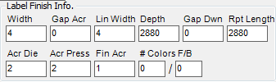

1. Enter your material into Part and enter the LF/ROL op code.
2. Click under the Qty field and fill out the formula. FT/R is feet per roll. You will have to take the roll length & divide by 12:

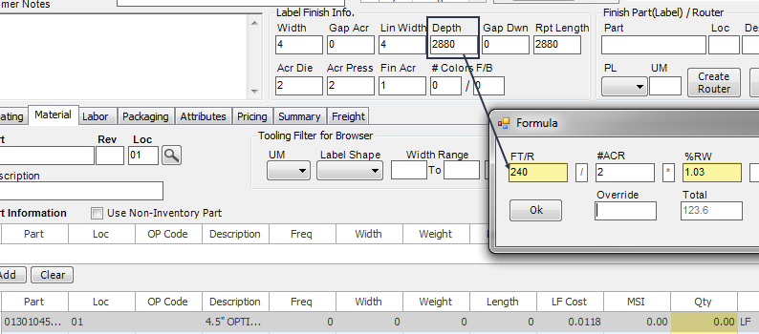

1. Next, **right click** on the Setup and click Add Comment Op Code.
2. Check the box you want and push ok.
3. Add the line and the material will separate into 2 lines.
4. Next enter your core, box & bag lines. All lines need to have a Freq entered & a Setup as 1.
   1. Frequency for core is the number of labels/core in thousands.
   2. Frequency for box is the number of labels/box in thousands.
   3. Frequency for bag is the number of labels/bag (same as box) in thousands.
5. Make sure you add all other materials you need (ink, shrink wrap, core labels, etc..)
6. When you are done adding your materials, go to the labor tab.
7. You can just pick a generic press for the continuous roll. Enter that into Workcenter, tab to magnifying glass, make sure it is highlighted and click select.
8. Click on the box under Op Code & click the RUNTIM2 op code.
9. Click in the box under Std Runtime & fill out the formula. You will need to fill out is the run speed & IN/R (inches per roll).

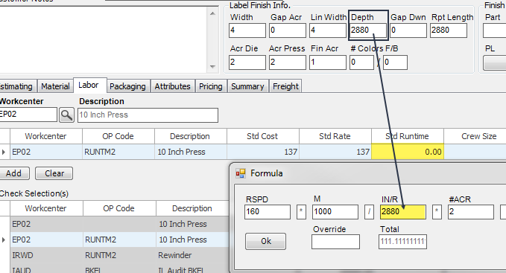

1. Right click under Setup (do not left click) & click Add Op Code Comments. Check the items you need. It will automatically add up the time for you and put in the hours (or you can manually enter the time).
2. Once you click Add, the press will split into two separate lines, one for run time & one for set up.
3. Now, add the rewind line. Enter IRWD into Workcenter, tab over to magnifying glass & browser will pop up. Make sure it’s highlighted & push select.
4. Click under the Op Code box & select the RUNTM2 op code.
5. Click under Std Runtime and fill out the formula (enter the run speed & inches/roll).
6. Do not add set up yet. Add the line first and THEN go to set up (otherwise it’ll split into 2 separate lines). Right click (do not left click) & click Add Comment Op Code & check the *RWD box and push ok.
7. The last line you need to add is the audit line. Enter IAUD into Workcenter, tab over to magnifying glass & browser will pop up. Make sure it’s highlighted & push select.
8. Click under OP Code & select BKFL.
9. Click under Std Runtime & under Override, manually type in 100,000
10. Add the line.
11. Next, go to the packaging tab and fill out everything you need.
12. Go to attributes & fill out everything you need there.
13. Enter shape as CONTIN
14. Go to Pricing tab and click refresh to get pricing.
15. For summary tab, you will need to move the lines up or down and rearrange them to put them in the order below (for the most part). You can either right click to Move up 1 or Move down 1 or if you highlight the number in the position column and enter the number you want that line to move to. If you want the line to move to 5, enter 4.5.

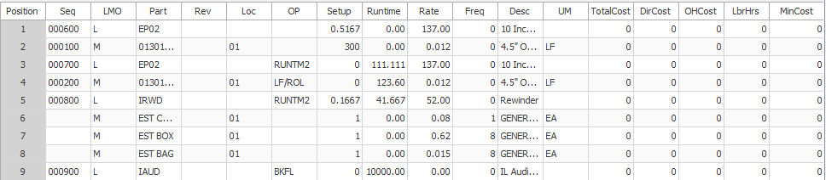

1. Go to the pricing tab & refresh pricing.
2. Estimate# 741 is an example to copy from.

# Continuous Roll (w/out slits)

1. Start by filling out the customer info, adding your quantities & then checking the correct location.
2. Make sure if you are filling out the Finish Part(Label) info your UM is RL.
3. You don’t need a die for a continuous roll so enter all the label finish info manually.

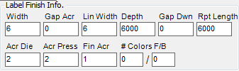

1. Enter your material into Part and enter the LF/ROL op code.
2. Click under the Qty field and fill out the formula. FT/R is feet per roll. You will have to take the roll length & divide by 12. For the %RW, just put 1:

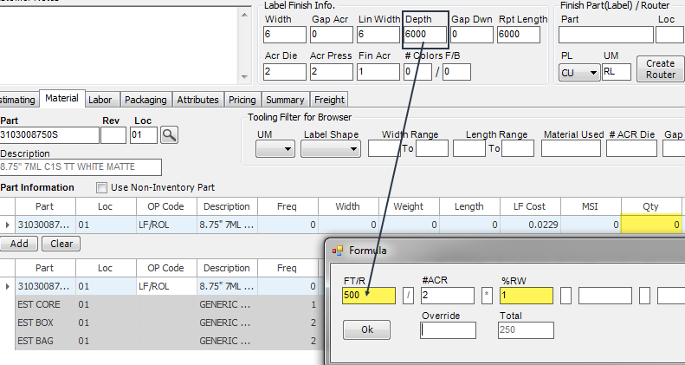

1. You do not need to add anything for setup since it’s not going to press.
2. Next enter your core, box & bag lines. All lines need to have a Freq entered & a Setup as 1.
   1. Frequency for core is the number of labels/core in thousands.
   2. Frequency for box is the number of labels/box in thousands.
   3. Frequency for bag is the number of labels/bag (same as box) in thousands.
3. Make sure you add any other materials you need (shrink wrap, core labels, etc..)
4. When you are done adding your materials, go to the labor tab.
5. Since it does not run through press, you do not need to add a press.
6. You do need to add the rewind line. Enter IRWD into Workcenter, tab over to magnifying glass & browser will pop up. Make sure it’s highlighted & push select.
7. Click under the Op Code box & select the RUNTM2 op code.
8. Click under Std Runtime and fill out the formula (enter the run speed & inches/roll).
9. Do not add set up yet. Add the line first and THEN go to set up (otherwise it’ll split into 2 separate lines). Right click (do not left click) & click Add Comment Op Code & check the *RWD box and push ok.
10. The last line you need to add is the audit line. Enter IAUD into Workcenter, tab over to magnifying glass & browser will pop up. Make sure it’s highlighted & push select.
11. Click under OP Code & select BKFL.
12. Click under Std Runtime & under Override, manually type in 100,000.
13. Add the line.
14. Next, go to the packaging tab and fill out everything you need.
15. Go to attributes & fill out everything you need there.
16. Enter shape as CONTIN
17. Go to Pricing tab and click refresh to get pricing.
18. For summary tab, you will need to move the lines up or down and rearrange them to put them in the order below (for the most part). You can either right click to Move up 1 or Move down 1 or if you highlight the number in the position column and enter the number you want that line to move to. If you want the line to move to 5, enter 4.5.

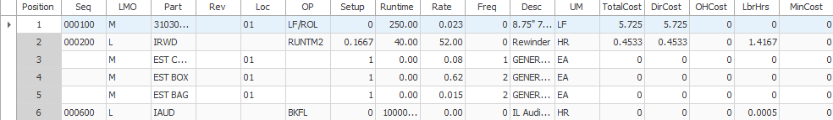

1. Go to the pricing tab & refresh pricing.
2. Estimate #747 is an example to copy from.

# 

# Contract Part Pricing

**Entering a Special Stock Quote**

1. To enter a special quote for a one-off price on a stock item you should go to the following menu item.
   * To be clear this menu would not be used for a bunch of special pricing that would be updated at once or a group of contract items. We will be handling that in a different way.

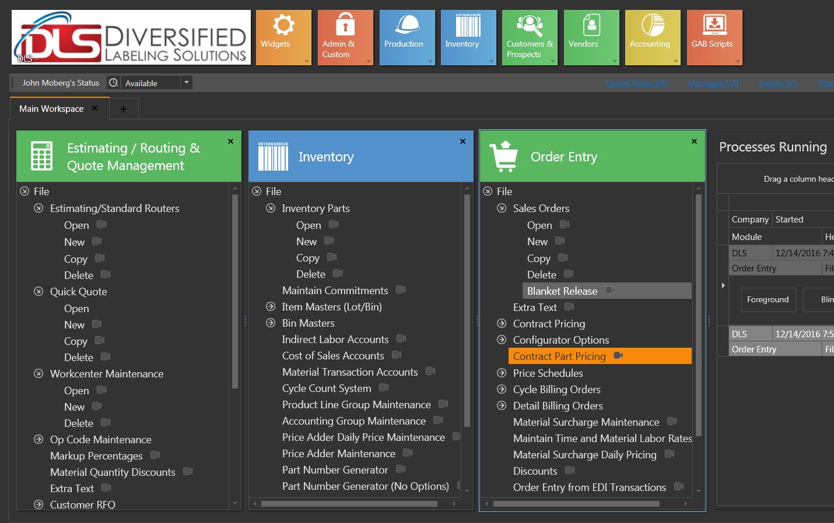

1. Entering this menu item will take you to this box

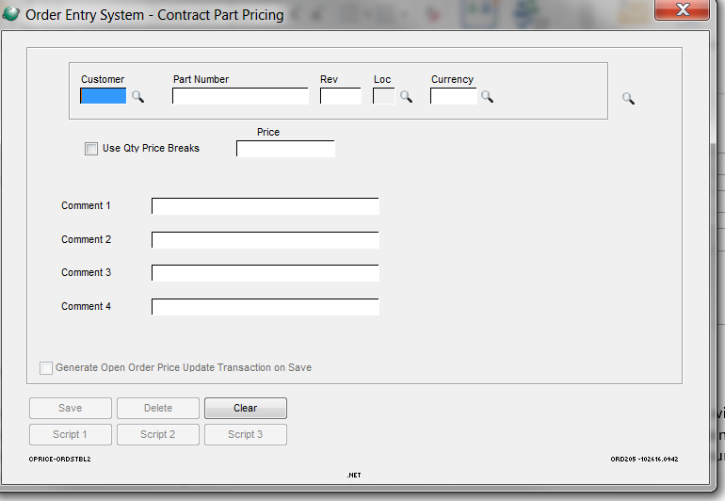

1. Enter Customer Name. In this case, the ACCPAC name.
2. Enter the part number for the stock item
3. click Use quantity price breaks

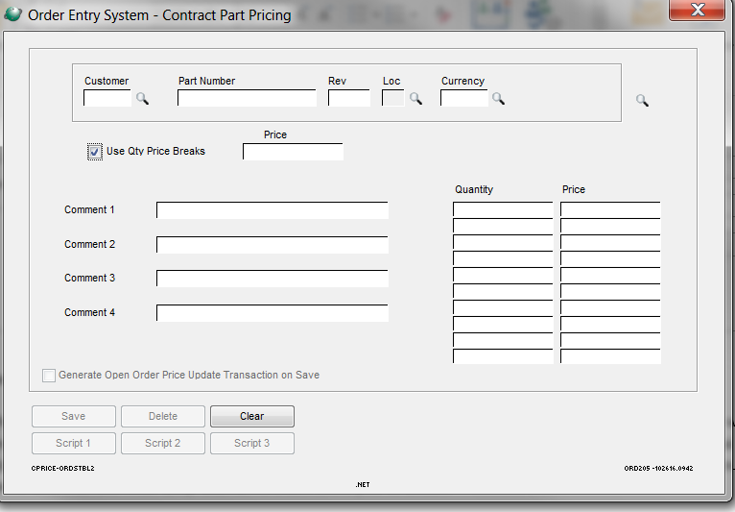

1. Enter quantity per M and price per M

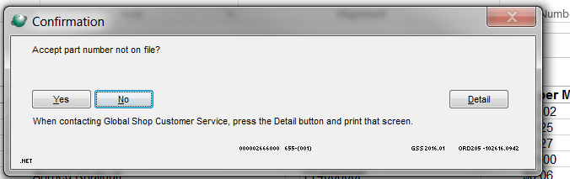

1. Say Yes to this confirmation and the price is entered.
2. As you can see when the order is entered and the quantity is entered below the quantity of the special price list the description next to price says inventory price. Please see below.

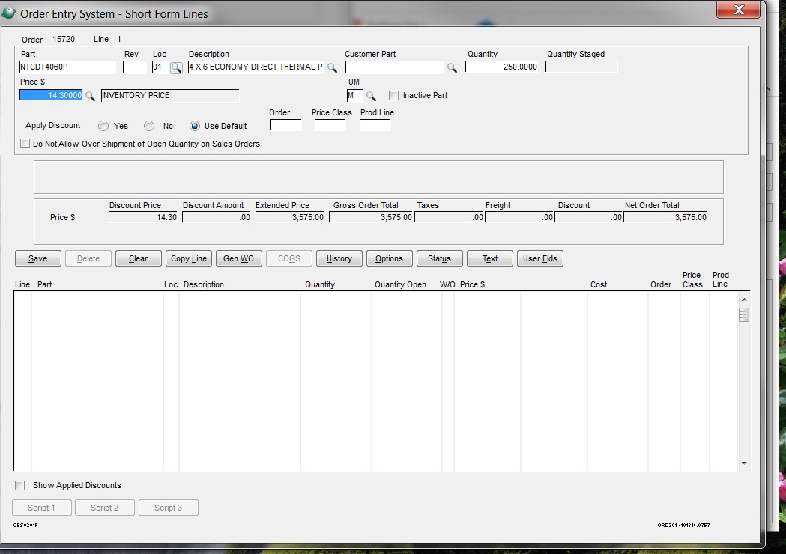

1. When the material is entered, you will see the box next to price appear and it will say Contract Price.

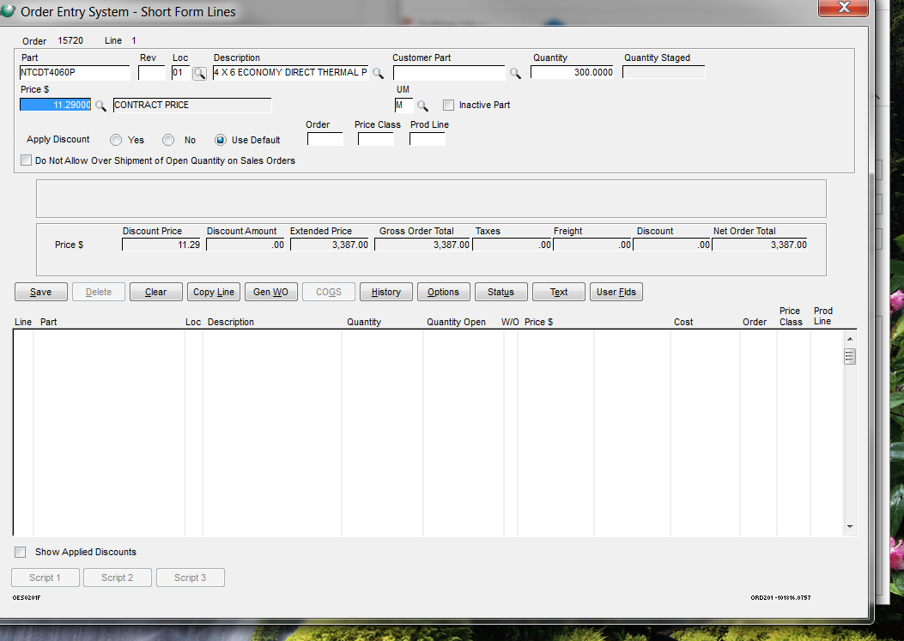

# 

# Copying an Estimate

1. When opening DICE Label Estimator, it will ask you if you want to open an estimate or create new. Even if you’re copying an estimate, push New.
2. Right click on the estimate you want to copy from & click Copy Est.

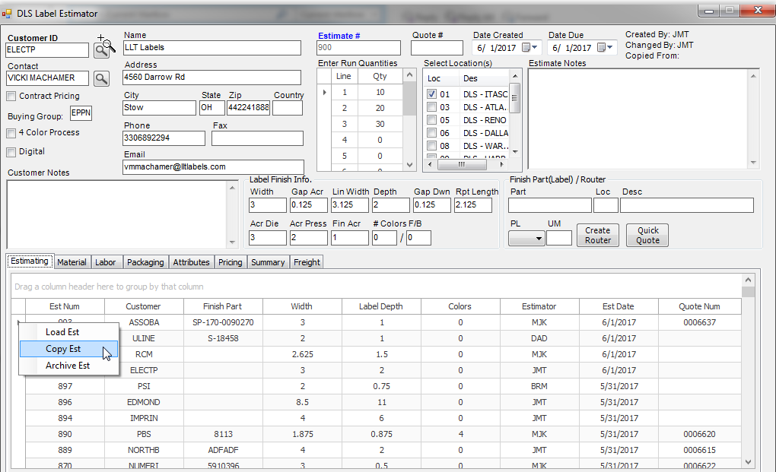

1. You’ll need to change the company info, quantities, and make sure the correct location is selected.

**MATERIAL TAB**

1. Go to the material tab, and change the die first. Enter/search for the die needed into the Part box. Do not tab over to the magnifying glass.

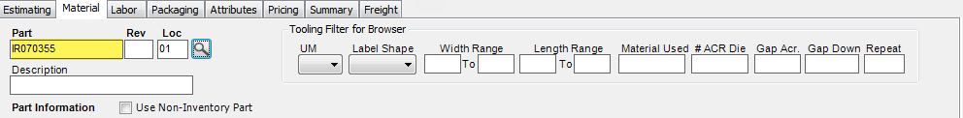

1. Go down to your lines & **right click** on the already existing die line. Click Change Part:

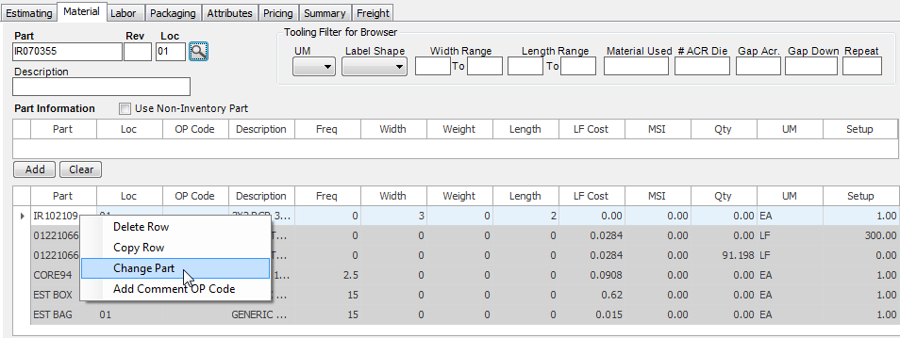

1. You will get the following box. Press YES. This is the only time you will push YES to this question.

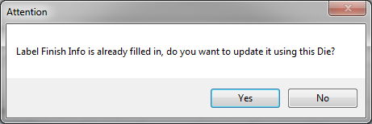

1. You will have to then change the rest of the Label Finish Info manually:

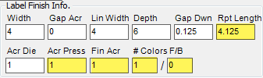

1. **Enter 1 into the setup**.



1. Update any other tooling, enter 1 into the setup for all tooling.
2. Next, change your material. Once again, entering the material in the Part box before changing the inventory part will pull up the browser faster. Do not tab over to the magnifying glass.
3. Go down to your lines & right click on the raw material line & click Change Part. It will bring the browser up with the part number you already typed. Select & both raw material lines will change.

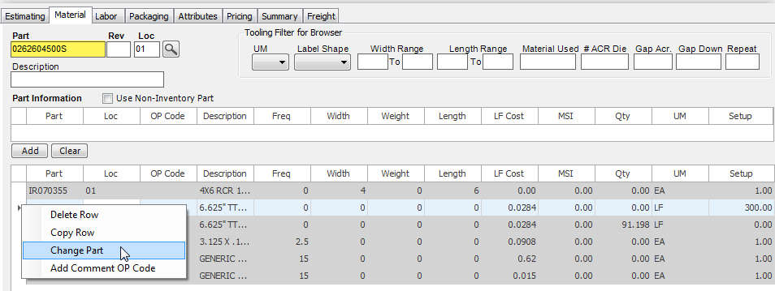

1. On the first raw material line, go to Setup, **right click**, click Add Comment Op Code:

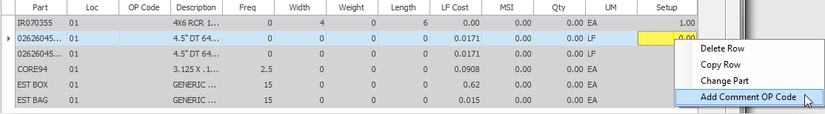

1. Select the setup footage that you need. Push ok.
2. Go to the next raw material line.
3. Renter the LF/ M op code (click under OP Code, find, & select LF/ M).

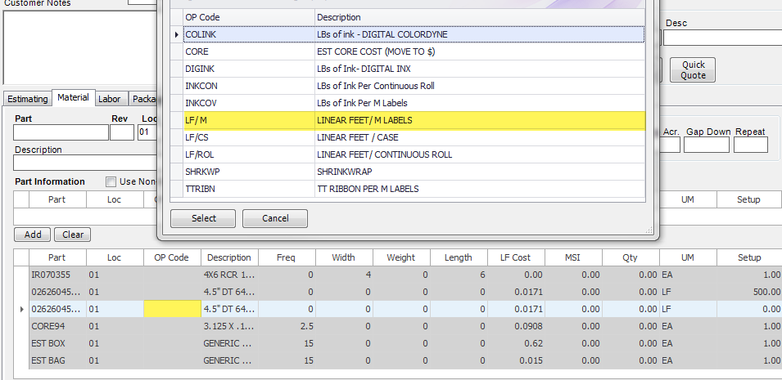

1. Go over to Qty, left click & enter formula.

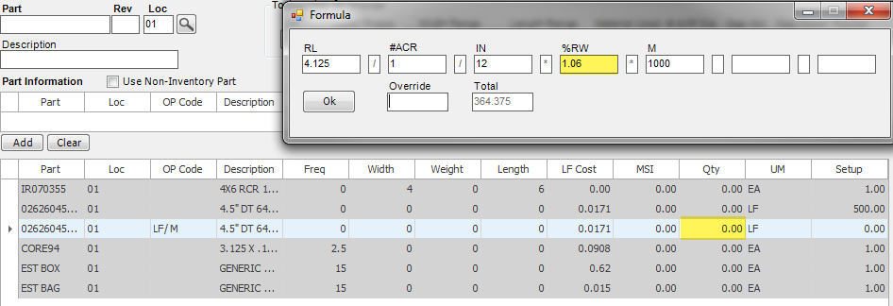

1. Next you will to change the core, box & bag. If you are not changing the inventory part, you will only have to change the frequency since Setup will already be 1.
2. If you are changing the core inventory part, type the new core into the Part box above, go back down to the existing core line, **right click** & click Change Part:

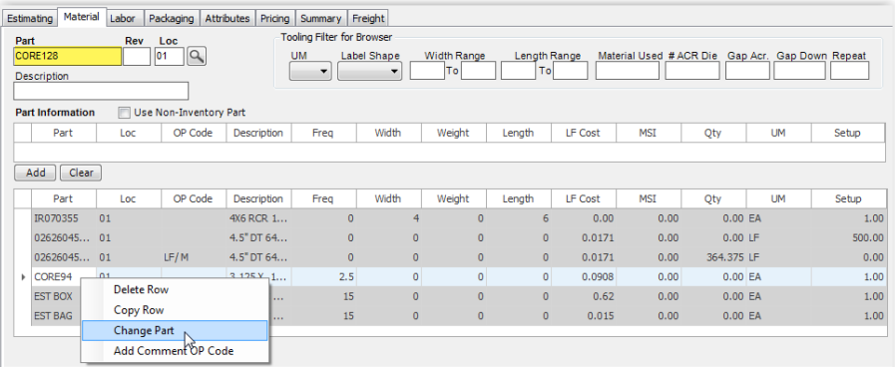

1. Once the new core is added, you will need to change the Freq (number of labels/roll in thousands) & you will need to change the Setup to 1:

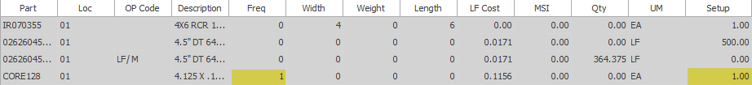

1. Do the same thing with box (frequency for box is the number of labels/box in thousands).
2. For EST BAG, you will just need to change the Freq to match the box. Setup will already be 1.

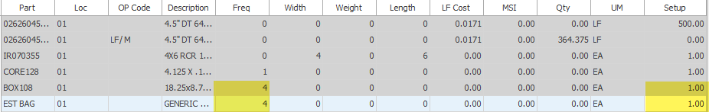

1. If adding ink, go up to the Part box, type your ink you need, tab over to the magnifying glass & select.
2. Click under OP Code & select correct ink op code.

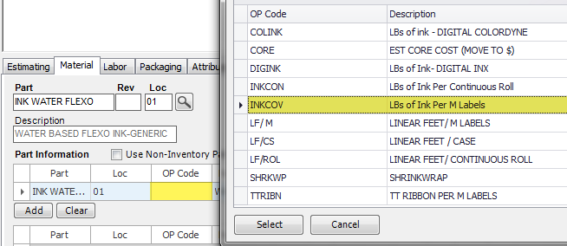

1. **Left click** in the box under Qty & fill out the formula (for 100% coverage enter 1 for %COV) & add the line.

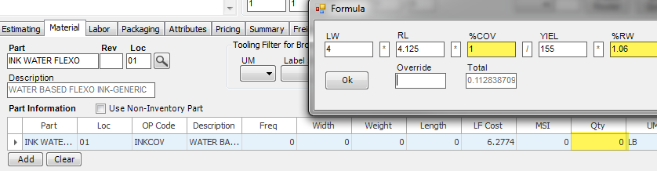

1. Add anything else you may need (other inks, other tooling, etc..).

**LABOR TAB**

1. Next, go to the labor tab. If you need to change the press, type your new press into the Workcenter (do not tab to the magnifying glass) & then go down to your line item & **right click** to Change WC:

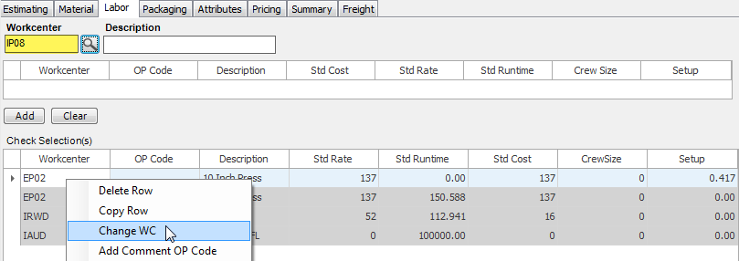

1. Both lines containing the previous press number will change.
2. Change the Setup in the first line of the press.
3. Right click under Setup & click Add Comment Op Code:

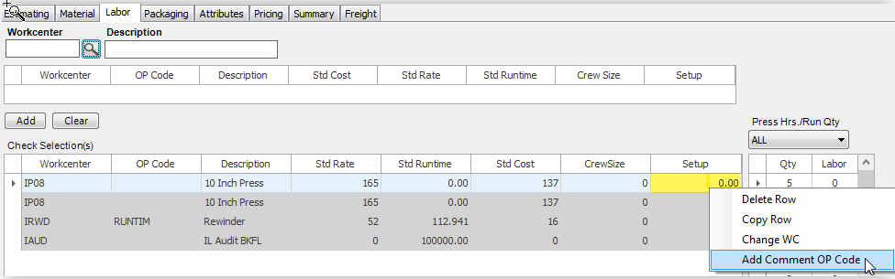

1. Check the items you need & push ok.
2. Go to the next line containing the press.
3. Click the box under Op Code & select the RUNTIM opcode.

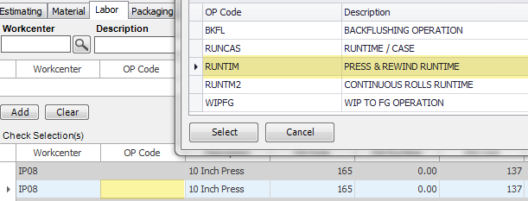

1. **Left click** under Std Runtime & fill out the formula:

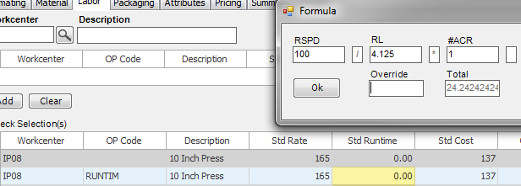

1. For rewind, **left click** under Std Runtime and refill out the formula. Then push ok.

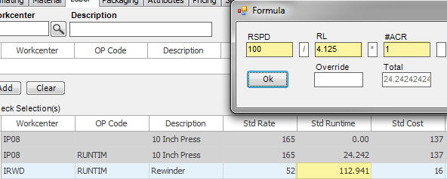

1. Go over to Setup, **right click**, click Add Comment Op Code & select *RWD to add 10 minutes for setup.

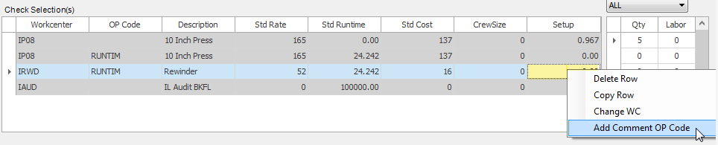

1. You will have to update the packaging & attribute tabs.
2. Make sure everything on the summary page is in the correct order.

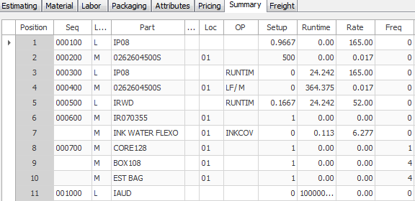

1. Go to the pricing tab & click refresh.

# Copying an Inventory Part

Copying a New Inventory Part Number

You can copy a different size part number from any location – or you can create a new one

To Copy:

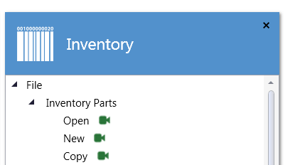

Type in part number you are copying and valid location

Type in new part number and location.

You must update the size in the description field Then you must change the Purchasing Conversion Factor

And Update the inventory Cost (see below) And the Width under Options screen

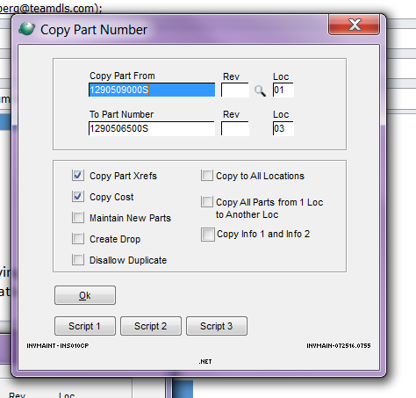

# Creating a New Inventory Part Number

TO CREATE A NEW PART NUMBER



Fill in on this screen:

Part number

Loc

Product Line  RM

Part description

UM = LF

Source – purchase to stock

Purch UM = MS

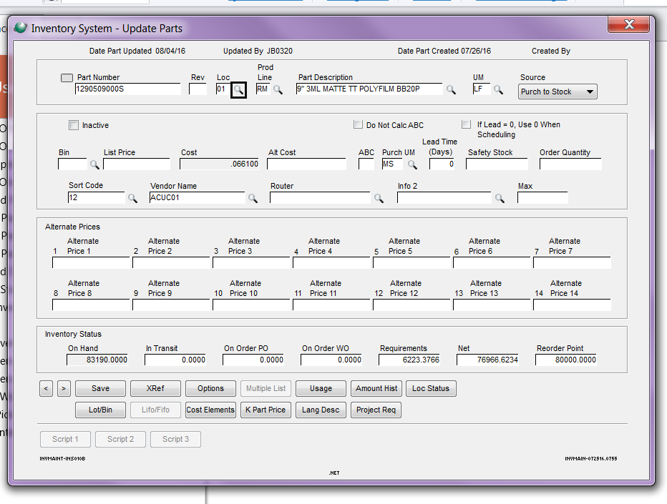

XRef - Fill in on this screen:

Vendor Code

Manufacturer’s part number

Manufacturer’s name

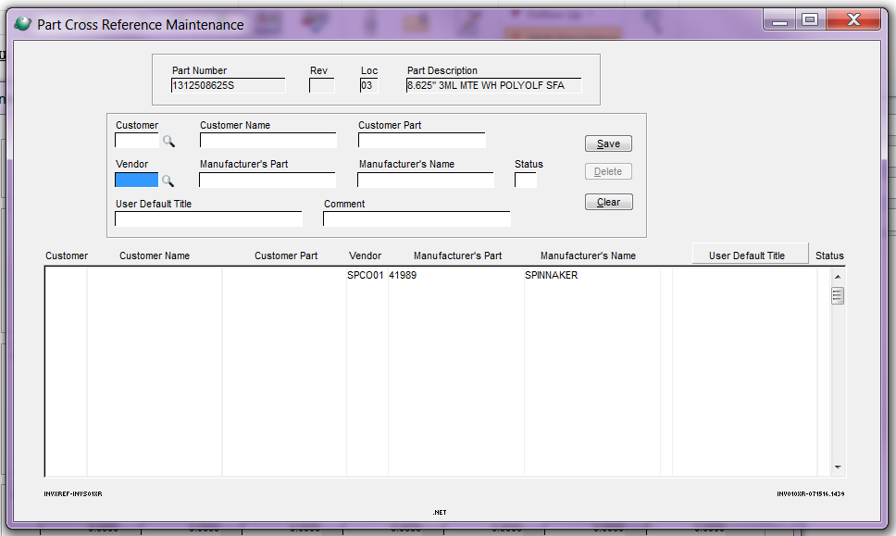

Options screen

Fill in:

Purchasing Conversion Factor

Which is (width * .012) = X   then 1 divided by X = purchasing conversion factor (use 5 decimal places)

Width (In)   -  only allows 4 decimal places

Est Issue UM  =  LF

Alternate Description 1 = any description that did not fit on the main screen description field

Alternate Description 2 = The shortened description that will print on all estimates (see other examples to use same format)

Check the boxes – Auto Number Lots when Receiving

And Do Not Backflush

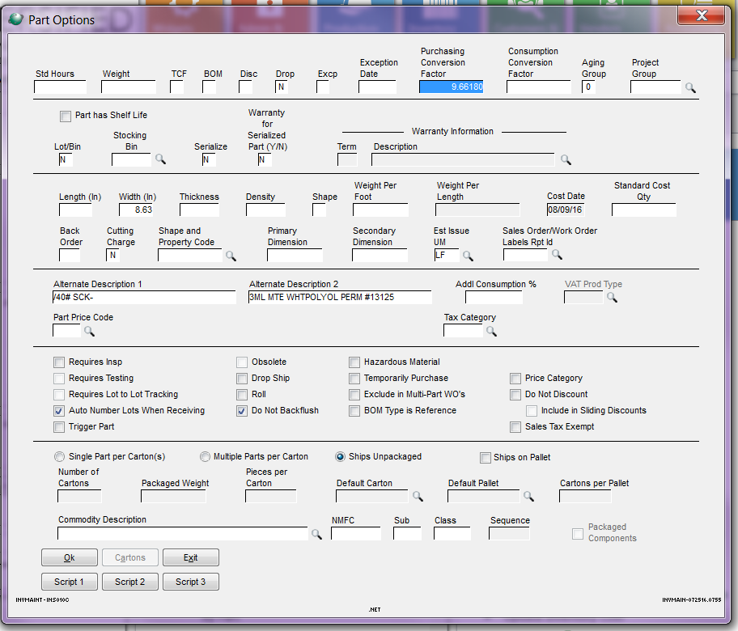

Update inventory Cost:

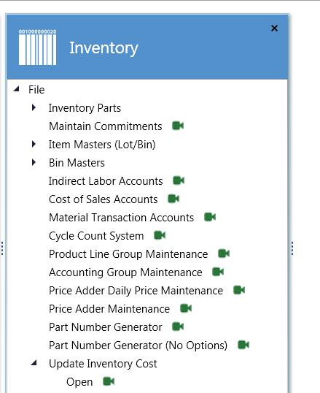←--------------------------------------

Click Cost Elements at the bottom

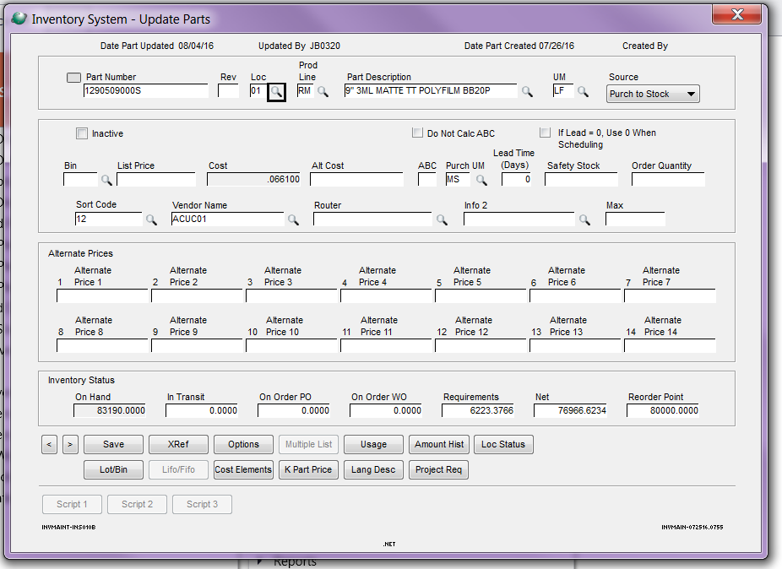

Fill in Material cost

Material cost = buy price MSI + any adders * .012 * width

.6118 * .012 * 9 = .06607

Any adders are - .003 for Mactac

.002 for Fasson plus freight adder

.004 for spinnaker

.003 for Wausau

If you do not know, they will be updated when the purchase order is placed for the item.

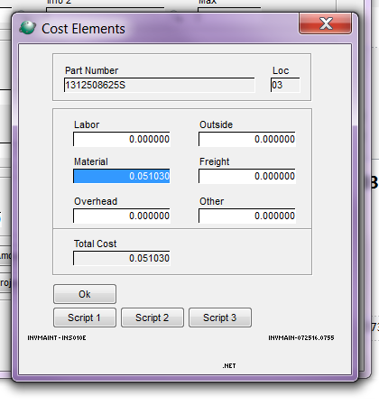

# Digital Quotes Walkthrough

1. Start by entering the company and the customer in the top left of the Label Estimator, enter quantities & location. Check 4 color process & digital check boxes on the top left under the customer information.
2. For digital estimates, you need to enter all the label finish info manually:

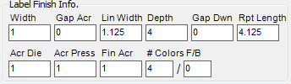

**MATERIAL TAB**

1. Go to the material tab & search (or enter) the material & width you would like to use into the Part box. Tab over to Loc, enter location & tab to the magnifying glass.
2. After you enter the material & width, click under OP Code and click the LF/ M op code.
3. Click on Qty & fill out the equation. Push ok.
4. Next, right click the box under Setup & click Add Comment Op Code & select the setup footage needed. Push ok.
5. Once you click add, the press work center will split into two separate lines. One for runtime & one for set up
6. Next, enter the digital ink (INK UV DIGITAL for the INX and INK WATER DIGITAL for the Colordyne). Make sure you click to correct Op Code once the ink is selected (DIGINK for INX & COLINK for Colordyne).
7. Then click under Qty and fill out the formula. You will need to fill out %Cov & switch the %RW:

* If there’s 50% ink coverage, enter 0.5)

1. Push ok & then add the line. (you can add the percent coverage by clicking in the description & typing in that box):



1. Next, enter the core, box & bag. For these, you need to enter the frequency and the **set up as 1**.

* Cores: frequency is the number of labels/core in thousands.
* Box & bag: frequency is the number of labels/box in thousands.

**LABOR TAB**

1. Next, go to the labor tab & enter the press (either **IP01 for INX** in IL (or TP1 in TX) or **IP02 for Colordyne** (or GP01 in GA). Once you select a press, click under OP Code and click the RUNTIM OP Code.
2. Next, click on Std Runtime & fill out the equation. Press ok.
3. Next, **right click** the box under Setup & click Add Comment Op Code & select the one(s) you need. Set up will be filled out automatically after you push ok.
4. Once you click add, the press work center will split into two separate lines. One for runtime & one for set up
5. Next enter rewind into the Workcenter (IRWD, TRWD or GRW1).
6. Click on the Op Code box & select the RUNTIM op code.
7. Click under Std Runtime & fill out the equation. Do not add set up yet, add the line first (otherwise the runtime & setup will split into 2 separate lines & rewind should only be one line).
8. Once the line is added below, **right click** (do not left click) under Setup, click Add Comment Op Code, & select *RWD to add 10 minutes.
9. If you have variable imaging, enter ISXP (for IL) under the work center & add the set up (in hours) manually or **right click**, click Add Comment Op Code & select SCISET.

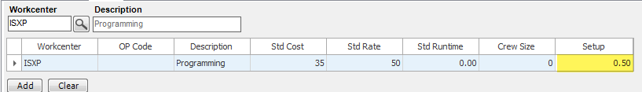

1. For the last step, go to the labor tab & enter the audit/backflush step. For IL, it is IAUD. Click the Op Code BKFL and enter 100,000 into the Std Runtime manually
2. Next is the packaging tab. Fill out what is needed.
3. Fill out attributes next.
4. Go to Pricing tab and click refresh to get pricing.
5. For summary tab, you will need to move the lines up or down and rearrange them to put them in the order below (for the most part). You can either right click to Move up 1 or Move down 1 or if you highlight the number in the position column and enter the number you want that line to move to. If you want the line to move to 5, enter 4.

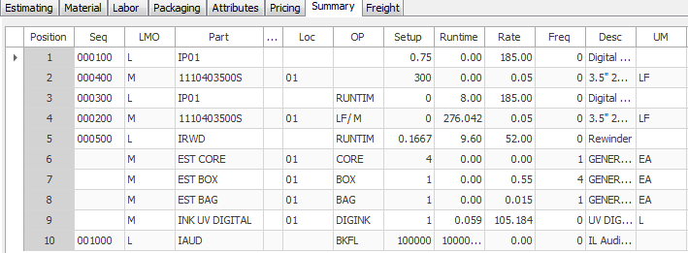

# Entering a New Die/Tooling

1. When entering a new die, go to the Inventory tab, then Inventory Parts, & click Copy:

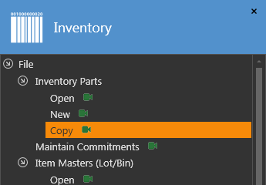

1. Enter a die to copy from & enter the location.
2. Type the new die number into the To Part Number box & add then add the location:

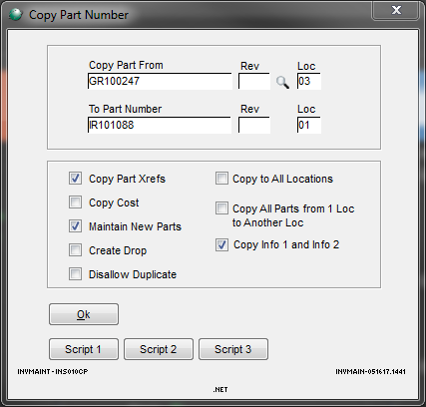

1. Push ok (leave everything checked).
2. Make sure everything on the following screen is filled out correctly):
   * Correct location
   * Prod Line needs to be ZT
   * Part Description needs to be filled out to match the new die information
   * UM is EA
   * Source is Purch to Stock
   * Check Do Not Calc ABC
   * Alt Cost needs to be .0001
   * Enter the correct sort code

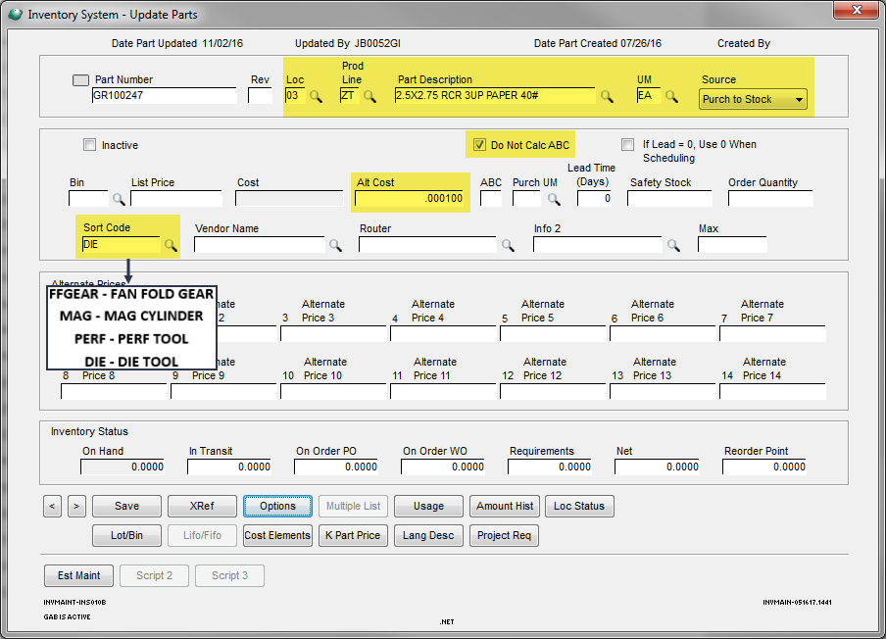

1. Go down to Options.
2. On this screen:
   * You will have to change Lot/Bin to N.
   * Change Length & Width to match the new die.
   * Make sure Do Not Backflush is checked.

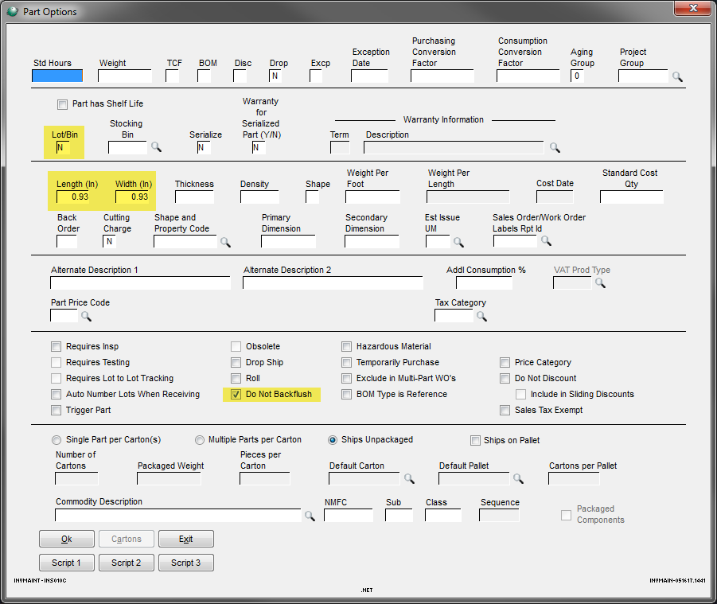

1. Click OK at the bottom.
2. Next open Est Maint at the bottom of the main Inventory System screen.
3. Go over to the Tooling tab & fill out all the information on this screen.
   * The Internal Lbl Width/Internal Lbl Length/Internal Lbl Numout is for information on 8.5”x11” sheets.

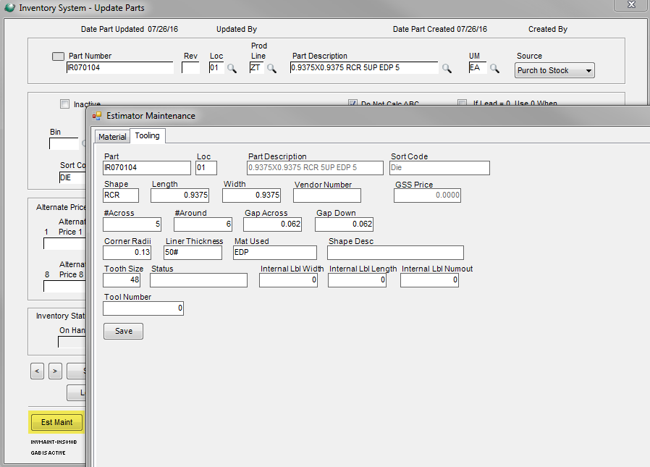

1. Push Save.
2. Then on the Inventory System main screen, click Save at the bottom of the screen.

# Fanfolding on Press

1. If you are fanfolding on press, the steps are a little different than finishing in rolls.
2. Under the material tab, you will need to add a fanfold gear as a tooling line:

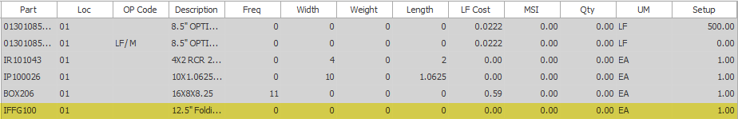

* The fanfold gear is the repeat length x the number of labels/fold.

1. Enter 1 into the set up for the fanfold gear.
2. You will only need a box for packaging unless the customer requests something else specific to that job.
3. When you right click under setup on the first raw material line (to Add Comment Op Code), make sure you check the FF box to add 300’.

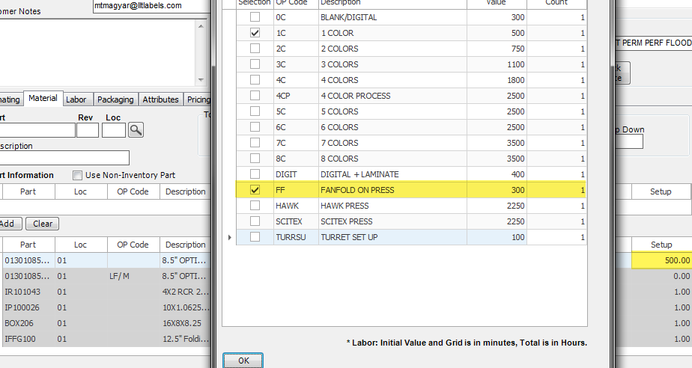

1. Enter a packer helper into the Workcenter instead of a rewinder line. Tab over to the magnifying glass & select the correct one (IPAC, GPAC, TPAC OR NPAC).
2. Enter the same Std Runtime as the press runtime (click on Std Runtime & enter it into the override box):
3. 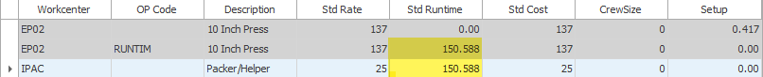 Next, we need to add a table top line. Search for the correct table top Workcenter, tab to the magnifying glass & select (ITAB, GTT1, TTAB, or NTT1).
4. Click under Std Runtime & enter 100,000 into the override box. Add the line.

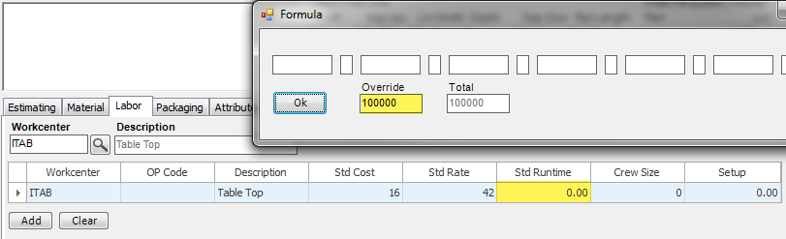

# Flexo Quote Walkthrough

1. Start by filling out the customer info, adding your quantities & then checking the correct location (checking one location at the beginning limits the materials & work centers (when selecting in the browser) to only one location). After the quote is finished, you can select all the other locations needed.

**MATERIAL TAB**

1. Go to the material tab & search (or enter) the die that you would like to use into the Part box. Tab over to Loc, enter location & tab to the magnifying glass. Once the die is selected, it will fill in some of the Label Finish Info automatically. You will need to fill in the rest manually.
   * Having this information filled in before anything else will help with auto filling the op codes when used.

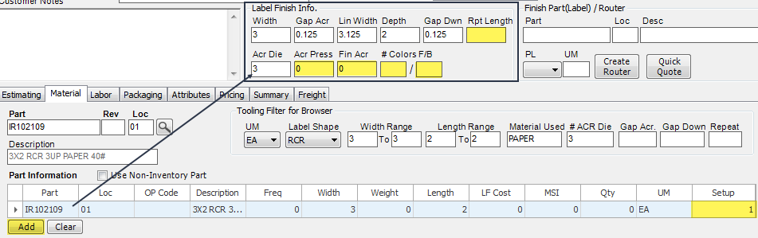

1. **Enter 1 into the setup field**. Add the line.
2. Add any other tooling you may need (perfs, mag dies, fan fold gear, etc..). **Add 1 for the setup for all tooling**.
3. Type the material & width you need into the Part box. Tab over to the magnifying glass.
4. Select a material.
5. Click the box under OP Code & select the LF/ M op code.
6. Click under Qty & fill out the formula. For example, if you are using 3% run waste, enter 1.03.

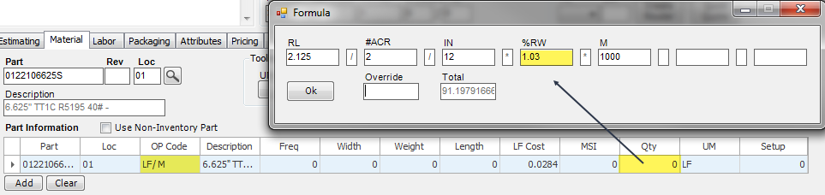

1. Next, **right click** (do not left click) under set up, select Add Comment Op Code, & check the correct box you need for setup feet. Click ok.
2. Once you click add the line, the material will split into two separate lines. One for runtime & one for set up.
3. Now, enter the core, box & bag. For these, you need to enter the frequency & the **setup as 1**:



* + Cores: frequency is the number of labels/core in thousands.
  + Box & bag: frequency is the number of labels/box in thousands.

1. Add any other materials you may need (ink, shrink-wrap, core labels, etc..)

**LABOR TAB**

1. Next, go to the labor tab.
2. Under the Workcenter box, you can either enter or search for the correct press needed (using a generic press is fine), tab to the magnifying glass & select.
3. Click the box under OP Code & select the RUNTIM op code.
4. Click on Std Runtime & fill out the formula. Press ok.

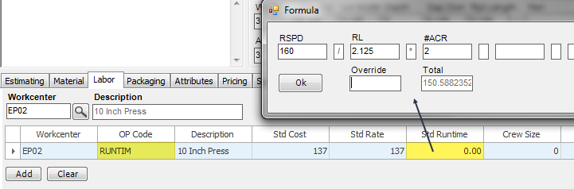

1. **Right click** (do not left click) under Setup, click Add Comment Op Code & check the boxes you need for setup. Press ok. The time will be changed into hours automatically.
2. Once you click add, the press work center will split into two separate lines. One for runtime & one for setup.
3. Next add finishing. Enter your finishing Workcenter & tab to the magnifying glass.
4. Click under Op Code & select the RUNTIM op code.
5. Click under Runtime to fill out the formula. Add the line
   * Do not add the set up yet because it will split the runtime and set up into 2 separate lines & finishing is just one line.
6. After the line is entered below, **right click** under Setup, click Add Comment Op Code, & check *RWD to add 10 minutes of set up.

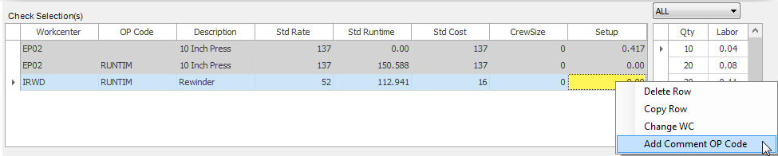

1. For the last step, enter the audit/backflush step. For IL, it is IAUD. Enter that into the Workcenter & tab over to the magnifying glass. Select the correct workcenter.
2. Click under Op Code & select the BKFL op code
3. Click under Std Runtime & in the override box, enter 100,000 manually.
4. Add the line.

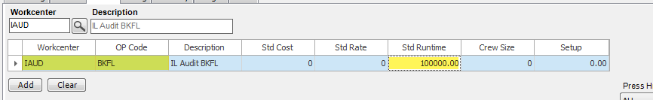

**PACKAGING TAB/ATTRIBUTES TAB**

1. Fill out the packaging & attributes tab depending on what the quote needs.
2. The Shape description is under the Attributes tab.

**SUMMARY TAB**

1. For summary tab, you will need to move the lines up or down to rearrange them & put them in a specific order (see below). You can either right click to Move up 1 or Move down 1 or if you can highlight the number in the position column & enter the number you want that line to move to. If you want the line to move to 5, enter 4.5.

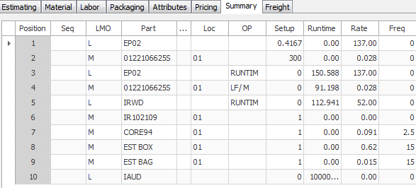

1. Go to the pricing tab & click refresh.

# Hawk Walkthrough

* Remember that the maximum print width for the Hawk is 13”.
* The press with the Hawk Unit can use either 10” or 13” tooling.

**MATERIAL TAB**

1. Enter all the material information just like any other flexo quote.
2. Enter die (to fill out Label Finish Info specs) & other tooling, material set up & runtime, additional ink – besides timing mark, cores/boxes/bags & anything else you may need.
3. When entering the material cut, keep in mind the waste edge should be a minimum of 0.375” on each side.
4. Add 3% run waste to the standard run waste.
5. For the Hawk, triple the setup waste footage (including the timing mark)
6. Add your ink (the Hawk requires a timing mark that will be trimmed off later) & varnish (to protect the image. If it’s being laminated, no varnish is needed). For standard ink, type INK WATER FLEXO or search in the browser. Tab over to the magnifying glass and the browser will open. Make sure INK WATER FLEXO is highlighted and push select.
   * The press with the Hawk unit on it has 6 towers & we can 4 color process print on this press.
7. Now you can add your ink (you do not need varnish for the Hawk). Enter digital ink for the Hawk, type INK UV DIGITAL into the part box. Tab over to the magnifying glass and the browser will open. Make sure INK UV DIGITAL is highlighted and push select.
   1. The Hawk press has 6 towers and we can 4 color process print on this press.
8. Click under OP Code and select DIGINK.
9. Click on the box under Qty & fill out the formula. %COV is the % of ink coverage (if there’s 5% ink coverage enter 0.05) & %RW is % run waste (if it’s 9% run waste, enter 1.09):

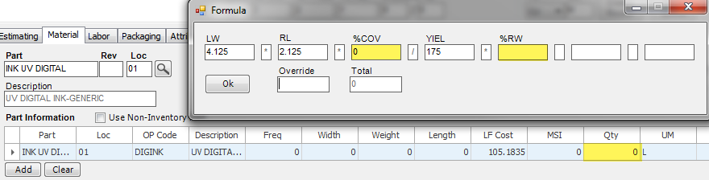

1. Make sure you add any other materials you need.

**LABOR TAB**

1. IP18 is the press with the Hawk unit on it. Enter that into Workcenter, tab to magnifying glass, make sure it is highlighted and click select.
2. The labor tab is filled out like any other flexo job except the specific press & you need to add a programming labor line.
3. For programming, enter ISXP into Workcenter, tab over to magnifying glass & browser will pop up. Make sure it’s highlighted & push select.
4. Right click on the Setup box (do not left click) click Add Comment Op Code & select SCISET to add 30 mins. If you need a different set up time, enter manually. The value is in hours.

**PACKAGING/ATTRIBUTES TAB**

1. Fill out everything you need there.
2. The attributes tab has a box where you can fill in the variable imaging description.
3. Go to Pricing tab and click refresh to get pricing.
4. For summary tab, you will need to move the lines up or down and rearrange them to put them in the order below (for the most part). You can either right click to Move up 1 or Move down 1 or if you highlight the number in the position column and enter the number you want that line to move to. If you want the line to move to 5, enter 4.

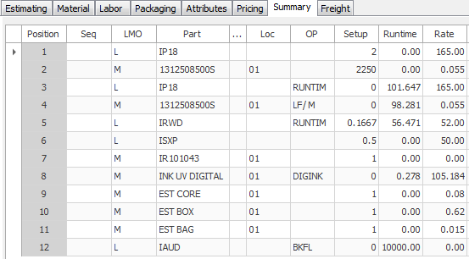

# Markup

* The initial markup will be a standard 10%
* If you click on the markup box on the first quantity, it’ll pull up a Markup Description. You can use this box to add one or multiple markups and describe what the markup is for
* If you right click in the box under Markup % & Description, you can add or remove a markup line
* You can also just type of the initial markup to add the desired markup
* You can then check which quantities you want these markups applied to at the bottom

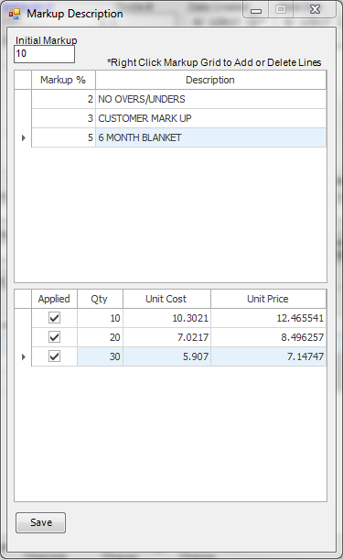

* Once you push save, it’ll automatically be added to the pricing tab & adjust all fields in grey

# New Customers/Contacts

* To set up new customers/companies into GSS, send them directly to Ashley Higi (Accounts Receivable).
* New contacts within a company that is already set up in GSS will go to James Cirigliano (Marketing Director).

# Non-Inventory Raw Material

If the material you need is not an inventory part item, simply click the Use Non-Inventory Par box and enter all the information manually:

* If you enter in the MSI price, the LF Cost will be calculated automatically.

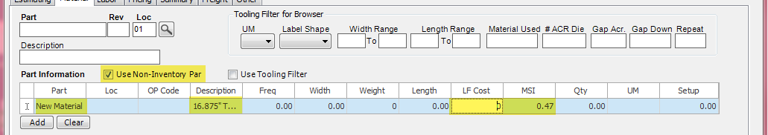

# 

# Offline TT Quote (custom item)

1. Start by filling out the customer info, adding your quantities & then checking the Chicago location.

**MATERIAL TAB**

1. Enter all the material information just like any other flexo quote.
2. Enter die (to fill out Label Finish Info specs) & other tooling – if you add tooling make sure the setup is 1, material set up & runtime, ink, cores/boxes/bags & anything else you may need.
3. For offline TT printing, you need to enter a ribbon. Either search or type it in under the Part box.
4. Once the correct ribbon is selected, click under to Op Code box & select the TTRIBN op code.
5. Click under Qty & fill out the formula. You will have to change the **#ACR to 1** (unless your label is finishing multiple across), fill in 2% for RW & enter the ribbon length (RBL):

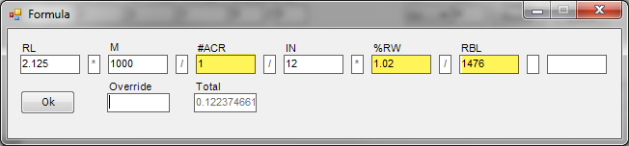

1. Add any other materials you may need.

**LABOR TAB**

1. The labor tab is filled out like any other flexo job except you need to add the TT Room line.
2. Enter ITTR in the Workcenter box.
3. Click under the OP Code & select the RUNTIM op code.
4. Click under Std Runtime & fill out the formula. Make sure you changethe **#ACR to 1** (unless your label is finishing multiple across). Add the line.
   1. See below for Run Speeds based on your roll length

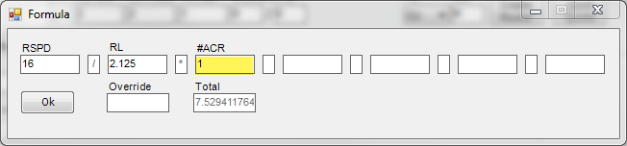

1. Go down to your newly added line & right click (do not left click) under setup & click Add Comment Op Code.
2. Select Offline TT room setup for 35 minutes (if it is a different time based on number of copies, add setup manually (the time is in hours)).

**PACKAGING TAB/ATTRIBUTES TAB**

1. Fill out these tabs accordingly.
2. Under the packaging tab, there is a box to type the variable imaging description.
3. Also under the packaging tab, you don’t have to check the ribbon box. That is for copacking a ribbon with labels.
4. Here’s an example of a correct order for the summary tab:

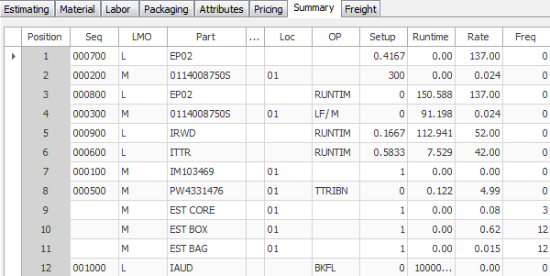

1. Go to pricing tab & refresh.
2. Estimate# 889 is an example to copy off.

# Offline TT Quote (stock item)

* Start by filling out the customer info, adding your quantities & then checking the Chicago location.
* You will have to enter all Label Finish Info manually.

**MATERIAL TAB**

1. You will not need to enter any tooling since we are just pulling a stock item & TT printing on it.
2. Enter the stock item into the Part box.
3. Manually enter 1 into setup



1. Next, enter the ribbon. Either enter it or search for it in the Part box.
2. Click under Op Code & select the TTRIBN op code.
3. Click under Qty & fill out the formula, 2% for run waste & make sure the **#ACR is 1** (unless the label finishes multiple across). RBL is the ribbon length:

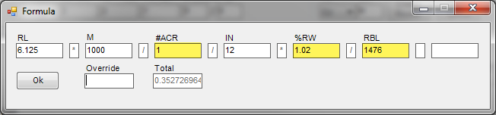

1. Enter cores/boxes/bags like a standard flexo quote.
2. Add any other material you need.

**LABOR TAB**

1. First enter finishing, if there is finishing. Enter the finishing info like any other flexo quote.
2. Next, add a TT Room line, enter ITTR in the Workcenter box.
3. Click under the OP Code & select the RUNTIM op code.
4. Click under Std Runtime & fill out the formula. Make sure you changethe **#ACR to 1** (unless your label is finishing multiple across). Add the line.
   * See below for the run speed based on your roll length

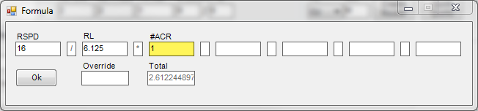

1. Go down to your newly added line & right click (do not left click) under setup & click Add Comment Op Code.
2. Select Offline TT room setup for 35 minutes (if it is a different time based on number of copies, add setup manually (the time is in hours)).

**PACKAGING TAB/ATTRIBUTES TAB**

1. Fill out these tabs accordingly.
2. Under the packaging tab, there is a box to type the variable imaging description.
3. Also, under the packaging tab, you don’t have to check the ribbon box. That is for copacking a ribbon in with labels.
4. Here’s an example of a correct order for the summary tab:

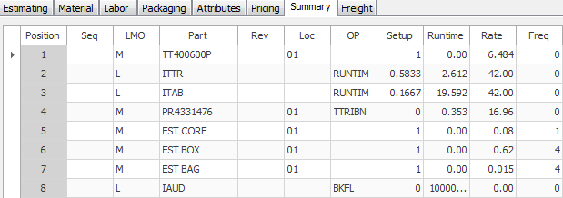

**Run speeds for Offline TT Jobs**

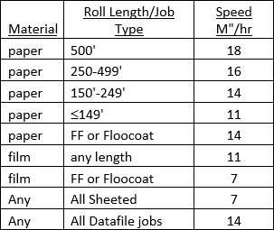

# 

# OP Code Explanation

The **RUNTIM** op code is for calculating the press run speed. The value represents how many labels (in thousands) per hour go through press.

RSPD = run speed

RL = repeat length

#ACR = how many across press this will be running

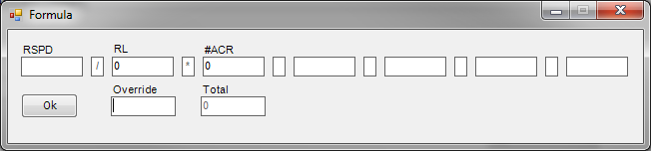

The **LF/ M** op code is for calculating the amount of material needed to run through press. The value represents the amount of material (in linear feet) it takes to make 1000 labels.

RL = repeat length

#ACR = how many across press this will be running

%RW = percent run waste

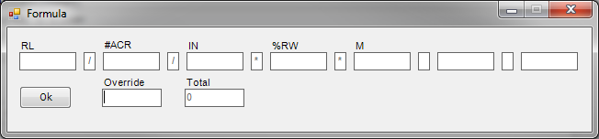

The **INKCOV** op code is for calculating the pounds of ink to cover 1000 labels.

LW = liner width

RL = repeat length

%COV = ink coverage

%RW = percent run waste

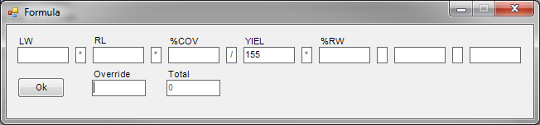

The **TTRIBN** op code is for calculating how many ribbons you need for 1000 labels.

RL = repeat length

#ACR = how many across running through the TT printer (usually 1 unless labels are finished multiple up)

%RW = percent run waste

RBL = ribbon length

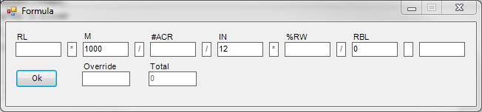

The **SHRKWP** op code is for calculating how much shrink wrap is needed for 1000 sheets.

#/PK = number of sheets per pack

SHTL = sheet length

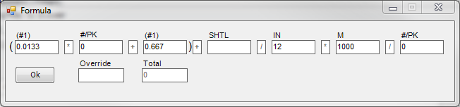

# 

# Packaging

Most common Cores & Boxes

|  |  |  |  |  |
| --- | --- | --- | --- | --- |
| **3" Cores** |  |  | **1" Cores** |  |
|  | Width |  |  | Width |
| CORE94 | 0.75" |  | CORE123 | 1" |
| CORE15 | 1" |  | CORE91 | 1.125" |
| CORE27 | 1.125" |  | CORE13 | 1.625" |
| CORE48 | 1.625" |  | CORE63 | 2.125" |
| CORE50 | 1.875" |  | CORE404 | 2.375" |
| CORE59 | 2.125" |  | CORE26 | 2.625" |
| CORE61 | 2.25" |  | CORE71 | 3.125" |
| CORE170 | 2.375" |  | CORE271 | 4" |
| CORE228 | 2.625" |  | CORE246 | 4.125" |
| CORE85 | 3" |  |  |  |
| CORE94 | 3.125" |  | **0.75" Cores** |  |
| CORE101 | 3.375" |  | CORE321 | 4.125" |
| CORE109 | 3.625" |  | CORE56 | 2.125" |
| CORE128 | 4.125" |  |  |  |
| CORE147 | 5.125" |  | **2" Cores** |  |
| CORE329 | 6.125" |  | Core344 | 1.125" |
|  |  |  |  |  |
| **Boxes** |  |  |  |  |
| BOX206 | 16X8X8.25 |  | BOX70 | 12.5X8.5X8.5 |
| BOX179 | 15X7.5X8.25 |  | BOX205 | 16X8X7.25 |
| BOX670 | 15X15X4.25 |  | BOX92 | 12X12X8.25 |

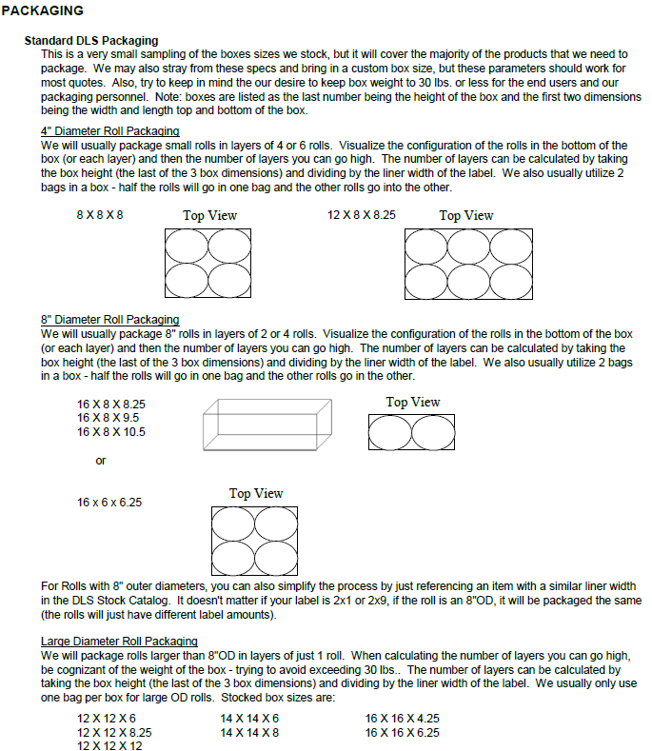

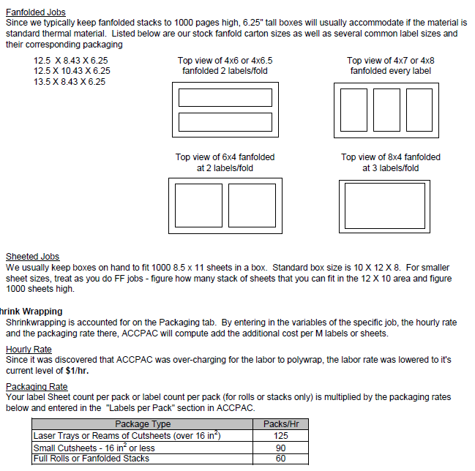

# 

# Scitex Walkthrough

* Remember that the maximum print width for the Scitex is 8.625”.

**MATERIAL TAB**

1. Enter all the material information just like any other flexo quote.
2. Enter die (to fill out Label Finish Info specs) & other tooling, material set up & runtime, additional ink – besides timing mark, cores/boxes/bags & anything else you may need.
3. When entering the material cut, keep in mind the waste edge should be a minimum of 0.375” on each side.
4. Add 3% run waste to the standard run waste.
5. For the Scitex, triple the setup waste footage (including the timing mark & varnish)
6. Add your ink (the Scitex requires a timing mark that will be trimmed off later) & varnish (to protect the image. If it’s being laminated, no varnish is needed). For standard ink, type INK SCITEX or search in the browser. Tab over to the magnifying glass and the browser will open. Make sure INK SCITEX is highlighted and push select.
   * The press with the Scitex unit on it has 6 towers.
7. Click under OP Code and select INKCOV.
8. Click on the box under Qty & fill out the formula. %COV is the % of ink coverage (if there’s 5% ink coverage enter 0.05) & %RW is % run waste (if it’s 9% run waste, enter 1.09):

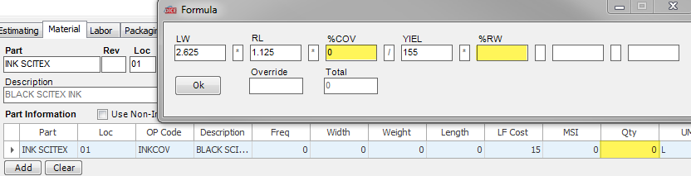

1. Do the same thing with varnish. Standard varnish part number is INK WATER VARNISH.
   * Keep in mind that there is no UV unit on this press so we cannot UV over-varnish
2. Make sure you add any other materials you need.

**LABOR TAB**

1. IP06 is the press with the Scitex unit on it. Enter that into Workcenter, tab to magnifying glass, make sure it is highlighted and click select.
2. The labor tab is filled out like any other flexo job except the specific press & you need to add a programming labor line.
3. For programming, enter ISXP into Workcenter, tab over to magnifying glass & browser will pop up. Make sure it’s highlighted & push select.
4. Right click on the Setup box (do not left click) click Add Comment Op Code & select SCISET to add 30 mins. If you need a different set up time, enter manually. The value is in hours.

**PACKAGING/ATTRIBUTES TAB**

1. Fill out everything you need there.
2. The attributes tab has a box where you can fill in the variable imaging description.
3. Go to Pricing tab and click refresh to get pricing.
4. For summary tab, you will need to move the lines up or down and rearrange them to put them in the order below (for the most part). You can either right click to Move up 1 or Move down 1 or if you highlight the number in the position column and enter the number you want that line to move to. If you want the line to move to 5, enter 4.5.

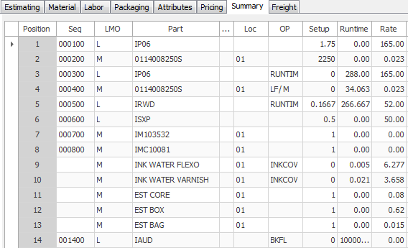

1. Go to the pricing tab & refresh pricing.
2. Estimate# 729 is an example to copy from.

# Sheeted Items

1. Start by filling out the customer info, adding your quantities & then checking the location that is needed.
2. If you are filling out the Finish Part(Label) / Router information, make sure that the PL is **LS** for laser sheet.

**MATERIAL TAB**

1. Enter all the material information just like any other flexo quote.
2. Enter die (to fill out Label Finish Info specs) & other tooling – if you add tooling make sure the setup is 1, material set up & runtime, ink, boxes (no cores or bags are usually needed) & anything else you may need.
3. For sheeted items, you will need to add shrinkwrap. Search or enter for the size width of shrinkwrap you need (for 8.5”x11” sheets, typically 18” shrinkwrap is used).
4. Click under Op Code & select the SHRKWP op code.
5. Next, click under Qty & fill out the equation. #/PK is the number of sheets/pack:

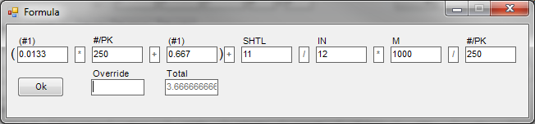

1. Add the line.
2. Next add chipboard. There is a generic chip board (EST CHIPBOARD), CHPD8.5X1120 for 8.5”x11” chipboard or CHPD8.5X1420 for 8.5”x14” chipboard. Select the inventory part that you need.
3. For frequency, enter the chipboard per case (typically it will be 0.25).
4. Under setup, enter 1.
5. Add any other material that is needed.

**LABOR TAB**

1. The labor tab is filled out like any other flexo job except you need to add a shrinkwrap labor line.
2. Enter the generic press (or the 10” sheeter press in IL is IP05 & the 18” sheeter press in IL is IP16).
3. Enter ISW (for IL, GSW for GA, NSW for NV, or TSW for TX).
4. Click under Std Runtime & under Override, calculate the labels packaged per hour. (Packs/Hr * Sheets/Pack). Add the line.
5. Once the line is added, go to the same ISW line & right click under setup, click on Add Comment Op Code & select SHRINK to add 10 minutes to the setup.

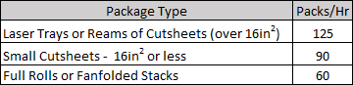

**PACKAGING TAB/ATTRIBUTES TAB**

1. Fill out these tabs accordingly.
2. Under the packaging tab fill out sheet/shrinkwrap information. Also, check Chipboard & anything else needed.
3. Here’s an example of a correct order for the summary tab:

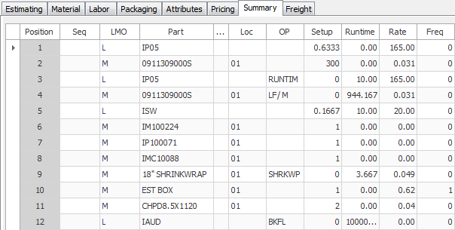

1. Go to pricing tab & refresh.
2. Example to copy from Estimate# 896

# 

# 

# Turret/Diecutter Finishing

1. If you are finishing the rolls on press, the steps are a little different than offline rewind or table top finishing.
2. Enter a packer helper into the Workcenter instead of a rewinder line. Tab over to the magnifying glass & select the correct one (IPAC, GPAC, TPAC OR NPAC).
3. Enter the same Std Runtime as the press runtime (click on Std Runtime & enter it into the override box):



1. Next, we need to add a table top line. Search for the correct table top Workcenter, tab to the magnifying glass & select (ITAB, GTT1, TTAB, or NTT1).
2. Click under Std Runtime & enter 100,000 into the override box. Add the line.



# 

# UL Labels

1. Start by filling out the customer info, adding your quantities & then checking the correct location (Chicago, Atlanta & Dallas are approved for UL).
2. Enter die (to fill out Label Finish Info specs) & other tooling, material set up & runtime, any ink, cores/boxes/bags & anything else you may need.
3. Enter all the material information just like any other flexo quote.
4. When entering the material cut, keep in mind the waste edge should be a minimum of 0.5” on each side.
5. All UL constructions require a core label. Enter that here (the inventory part is CORE LABEL). Enter setup as 1.
   * Frequency for core label is the number of labels/core label (same as core) in thousands.



1. Make sure you add any other materials you need (shrink wrap, etc..)

**LABOR TAB**

1. The labor tab is filled out like any other flexo job.
2. You can pick a generic press here.
3. For rewinding, there is a maximum speed of 80 & use the highest rewind rate, even if the job qualifies for table top rewind.

**PACKAGING/ATTRIBUTES TAB**

1. Fill out everything you need there.
2. Under the packaging tab, there is a box to check for core labels.
3. Go to Pricing tab and click refresh to get pricing.
4. For summary tab, you will need to move the lines up or down and rearrange them to put them in the order below (for the most part). You can either right click to Move up 1 or Move down 1 or if you highlight the number in the position column and enter the number you want that line to move to. If you want the line to move to 5, enter 4.

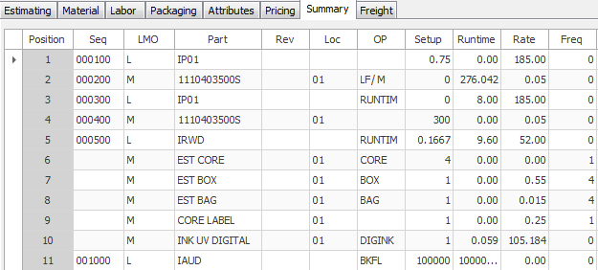

1. The minimum base markup for UL work is 1.21
2. The minimum CTO for UL work is $100

# Combo Router – Set up Line

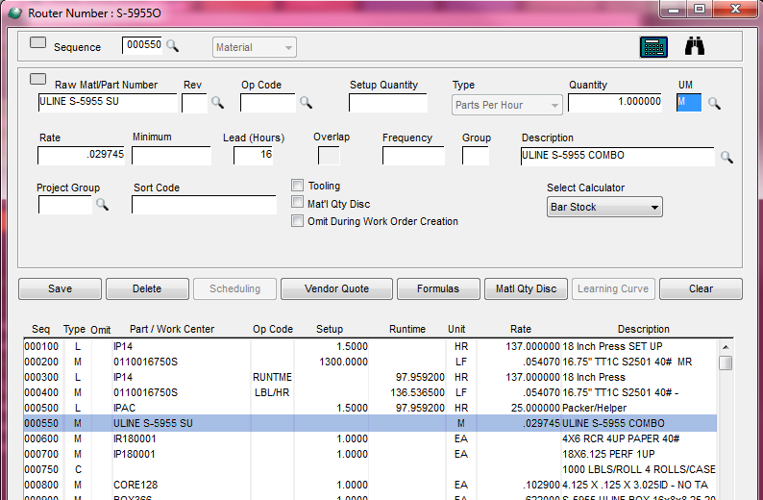

Step 1 (create an inventory part):

1. Under Inventory, click the arrow for inventory parts and click new

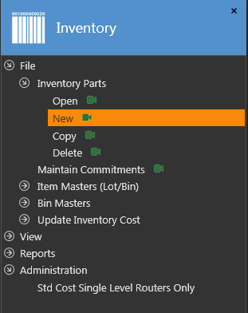

This screen will open and you will fill out the following:

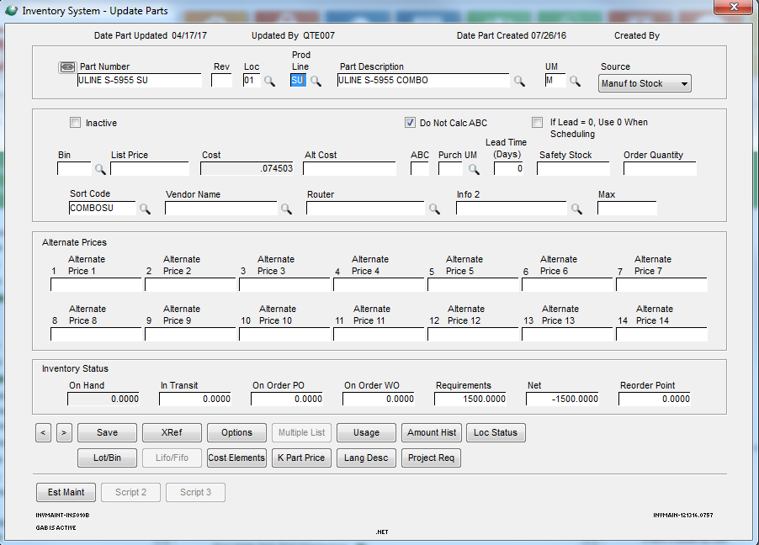

1. Fill out the part number to contain the DLS part number and SU for set up
2. Fill out location (01 in this case)
3. **ENTER THE PRODUCT LINE (SU FOR COMBO..)**
4. Add a part description
5. UM is M
6. Source is Manuf to Stock
7. Cost will be empty at first
8. Enter COMBOSU in sort code
9. Save

Second step (create set up router):

1. Go to Estimating/Standard Routers
2. Click New
3. Enter the inventory item you just created
4. Enter a similar number of a previous combo run (ULINE S-7437 SU in this case)
5. Enter the quantity
6. Click lines

Line 1 (Press Setup):

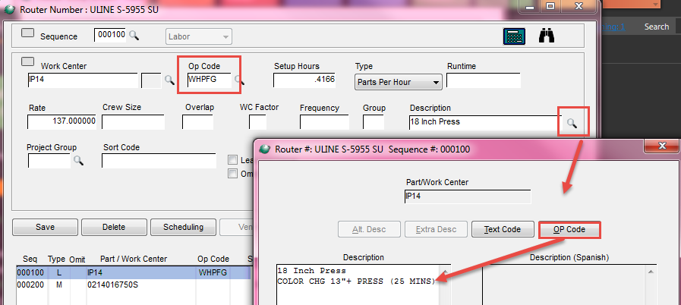

1. Enter the press under work center
2. Under op code, manually type WHPFG
3. Click on the magnifying glass next to the Description (on right)
4. Open up the Op Code
5. Enter the color change for the correct press
6. Save
7. X out of the box
8. Take the total minutes, divide by 60 & enter the new number into Setup Hours (25/60=0.4166)
9. Save Line

Line 2 (Material Setup):

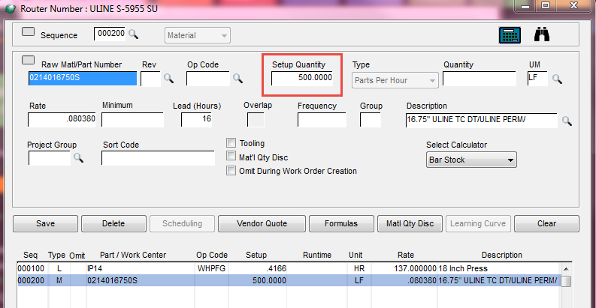

1. Enter material into Raw Matl/Part Number
2. Enter the amount of material it takes to set up 1 job (500’ for 1 color)
3. Save line
4. X out of lines
5. Save router in router screen (bottom left)

Third step (create pricing for router):

1. Under Inventory
2. Click arrow next to Administration
3. Open up Std Cost Single Level Routers Only

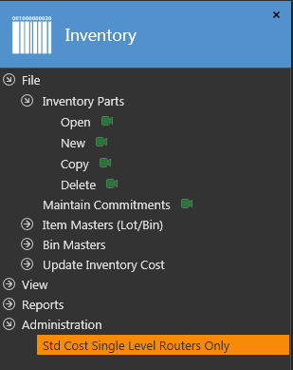

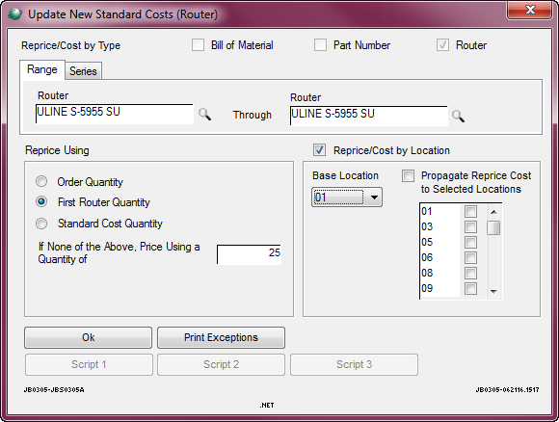

1. Enter router name in to Router, will populate next box
2. Check First Router Quantity
3. Check the Reprice/Cost by Location
4. Enter Base Location (01 in this case)
5. Push OK
6. This screen will pop up, press Yes:

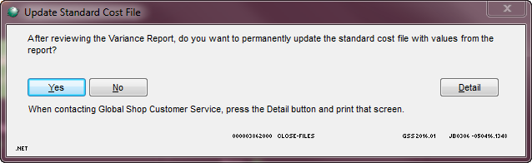

Fourth Step (go to original router):



1. Create a new material line
2. Change sequence number to be right before tooling
3. Enter 1 into quantity
4. Rate should automatically populate
5. Save Line